OUTREACH ASSESMENT WEB PORTAL

Bhavya.batra | CS6001 | December 16, 2016

Section 1: Introduction 3

Section 2: Referenced Systems 5

Section 3: Design of SWE Outreach Assessment Web Portal 8

Section 4: Architecture 24

Section 5: SWE OAWP at Runtime 27

Section 6: Activity Diagrams 45

Section 7: Use Case Diagram 47

Section 8: Sequence Diagrams 48

Section 9: Testing 48

# Section 1: Introduction

* 1. SOCIETY OF WOMEN ENGINEERS

Society of Women Engineers is a non-profit organization. It helps in empowering women to succeed and advance in the field of engineering. SWE offers training and development programs, networking opportunities, scholarships, and outreach and advocacy activities. According to the mission line of SWE “Stimulate women to achieve full potential in careers as engineers and leaders, expand the image of the engineering profession as a positive force in improving the quality of life, and demonstrate the value of diversity.” And Vision is “To be key to the success of women in engineering and technology.”

Primary Goals of SWE are: -

Professional excellence

Globalization

Advocacy

SWE offers support at all levels, from K-12 outreach programs and collegiate sections to professional development in the workplace.

* 1. OUTREACH ASSESSMENT WEB PORTAL

After-event surveys are most common type of feedback practice which SWE teams use. These surveys need to be filled by all the participants. Also, these surveys cover wide range of participants from Students to Parents, and from Teachers to Volunteers. Surveys include open-ended questions, multiple choice questions, agree/disagree, true/false and so on. After that, responses are collected and results are analyzed. These results are very useful in marketing, maintaining records, getting sponsors.

This project is an effort to ease the current SWE outreach assessment process.

Project involves formulation of a web portal using Dot net supported technologies. The high level features of this system will be: -

* + 1. Survey Generator.
    2. Feedback Analysis.
    3. Users Management.

Although, similar system has been developed by CS5364 (14-15) students. But this system will make an attempt to overcome the flaws of existing system and enhance quality.

# Section 2: Referenced Systems

Couple of following Systems are referred while developing SOAWP

**System # 1**

AUTOSWE – This system was developed by YongJi Li (May 2016). This is Android based mobile app. This app is built upon AWS Mobile SDK and AWS Dynamo DB. This app helps SWE members in creating, deploying and taking the surveys of SWE events. Following the activity diagram of AutoSWE: -

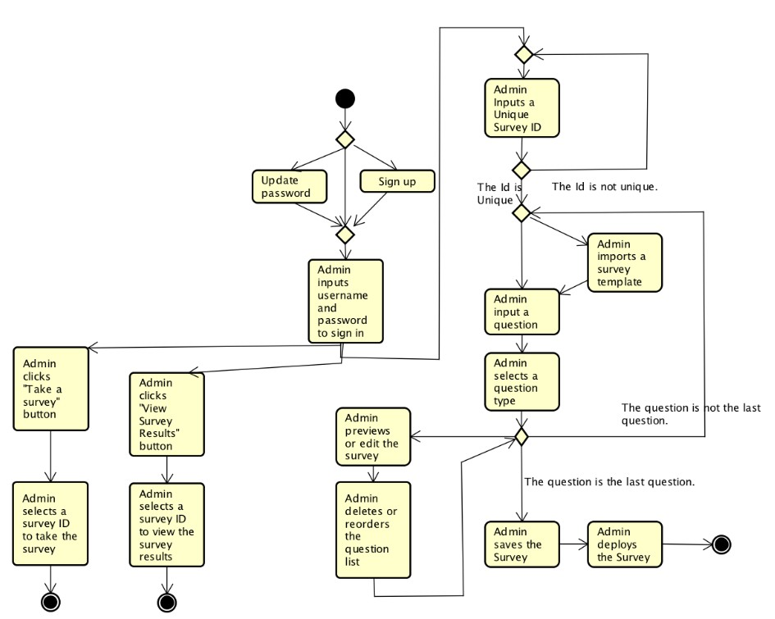

**System # 2**

Similar kind of system was developed as a project for CS5364 (2014-2015). Features of this system are: -

1. User Management
2. Paper Survey Generation
3. Report Viewer

Underneath is the state chart diagram of existing system which gives a high level view of the system.

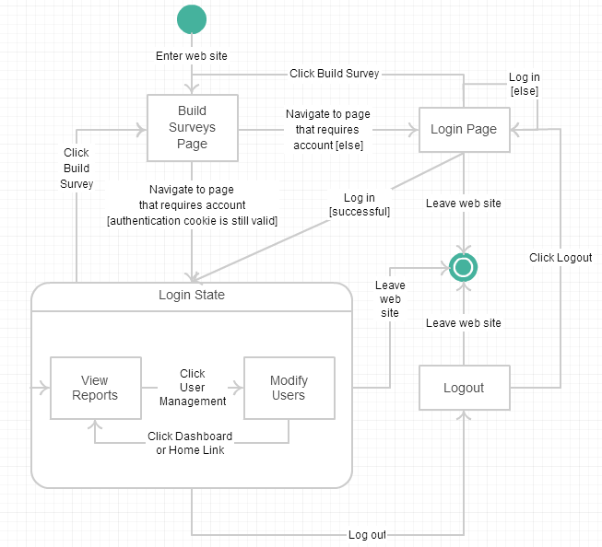

However, this system makes an attempt to address basic necessities of SWE but somewhere fall short to deliver robust mechanism. And following were the type of issues that were blocking the smooth functioning of system.

* Admin Login Crashes.
* UI bugs.
* Lack of User Access Controls.
* Report Viewer Bugs.

# Section 3: Design of SWE Outreach Assessment Web Portal

* 1. DESIGN FRAMEWORK

SWEN OAWP is a basically a web platform from which SWE members can generate and issue paper and/or electronic surveys, get and post feedback, and view feedback in form of graphical reports depending upon their access privileges. Access privileges can be controlled by Outreach Administrator. So, all this mechanism has 3 basic internal design layers: -

* Presentation Layer
* Logical Layer
* Database Layer

Technology which is efficiently satisfying requirements of this SWE OAWP is Model-View-Controller design patterns.

* Model: Model (in MVC) can be said as first definition of entire software system. It encapsulates the behavior the behavior and data of the application domain. It interacts with controller for performing any course of action and interacts with views to display information. In our project, Model plays vital role in abstraction of database layer.
* Controller: Controller is the logical of module entire software system where actual algorithms are implemented. It contains all the business logic in SWE OAWP and handles interactions with user.
* View: The view manages the display of information. In SWE OAWP, views will be managing presentation layer.

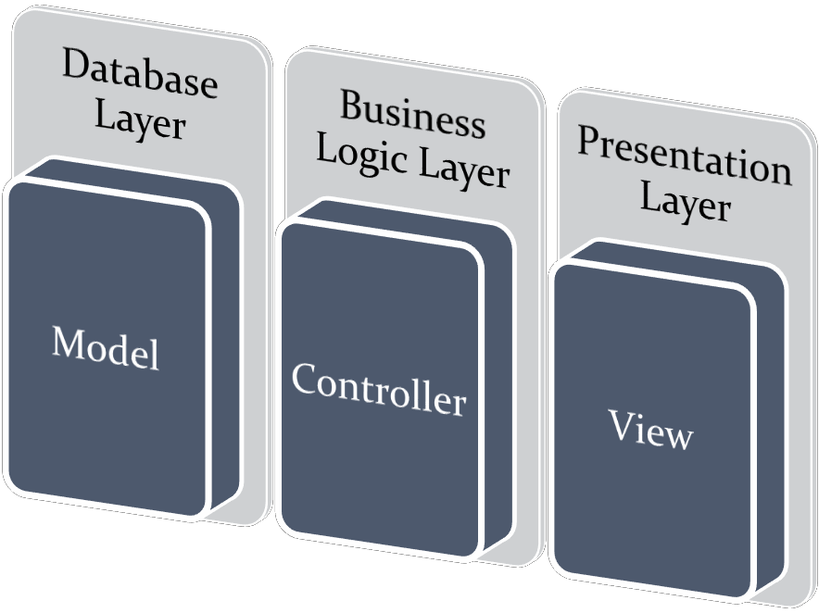

In SWE OAWP, we are using Active MVC Design.

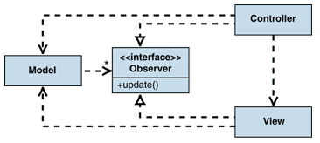

In SWEN OAWP, we are using AWS based Dynamo DB. It is NoSQL and cloud based database. It has high durability, availability and synchronous replication across multiple datacenters.

* 1. SWE OAWP DESIGN (4/24/2017)
     1. Class Diagram

Following are the classes and methods in SWE OAWP.

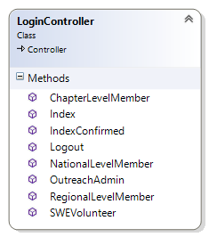 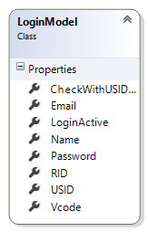 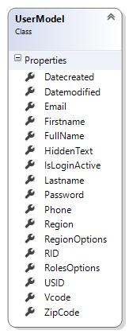

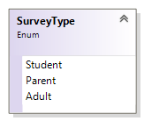

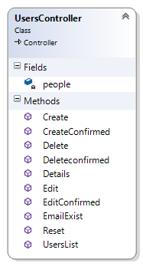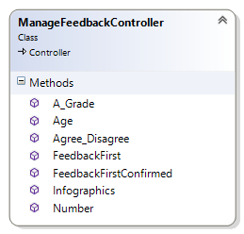

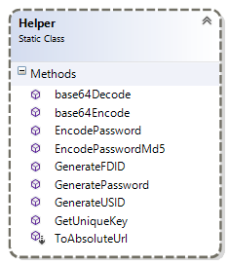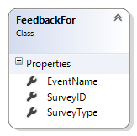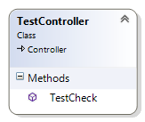

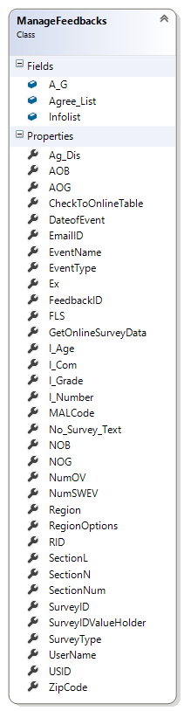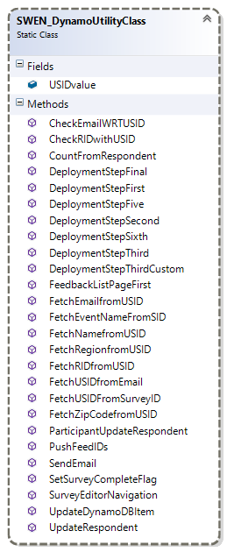

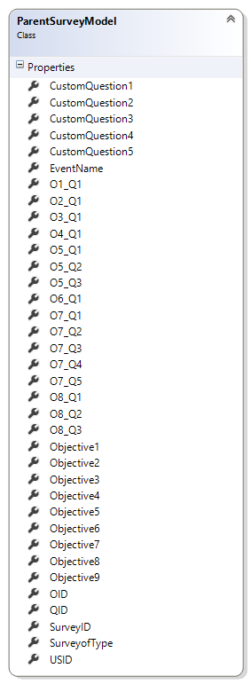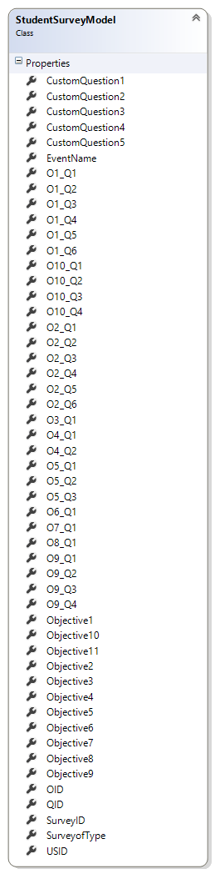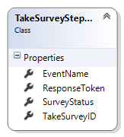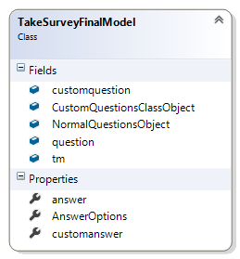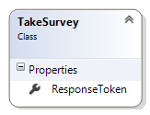

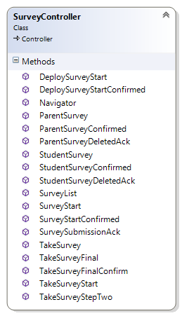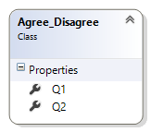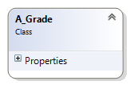

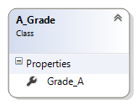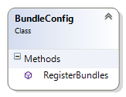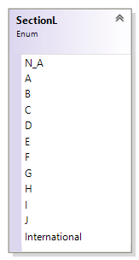 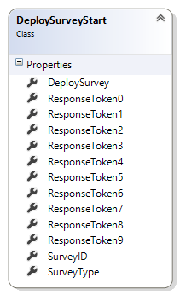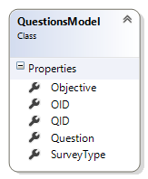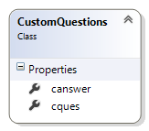

* + 1. AWS Dynamo DB Design

AWS Dynamo DB is the No SQL Database, that means that table structure is never permanent. Partition Keys (and Sort keys) are the primary key of tables. At the time of table definition, declaration partition (and Sort Key) is mandatory. Rest of attributes may change according to the item characteristics.

Data Table: User

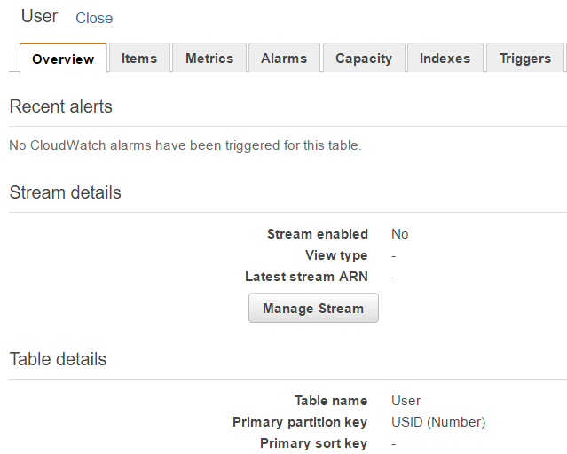

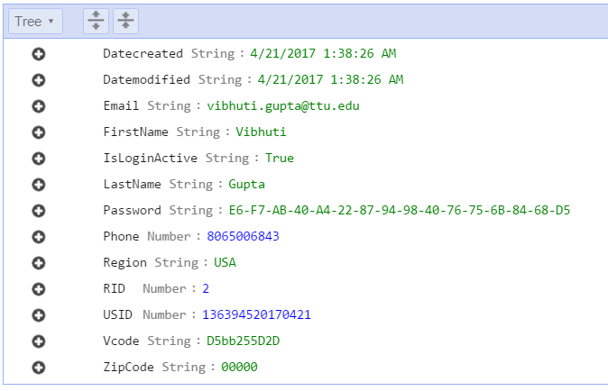

Data Table: Surveys Feedback

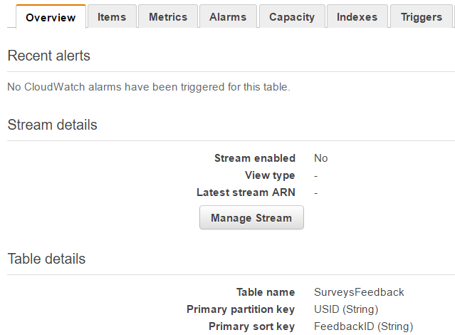

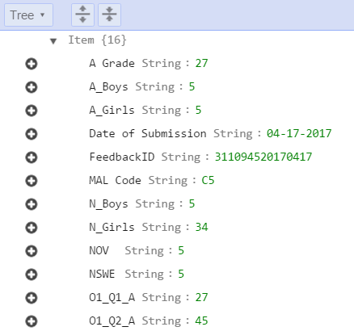

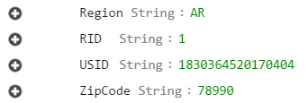

Data Table: Survey Catalog

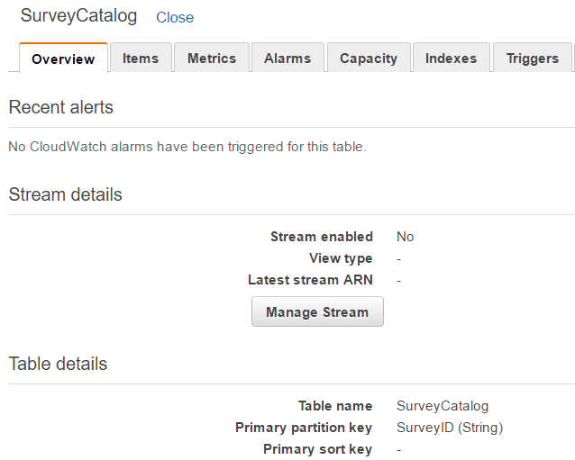

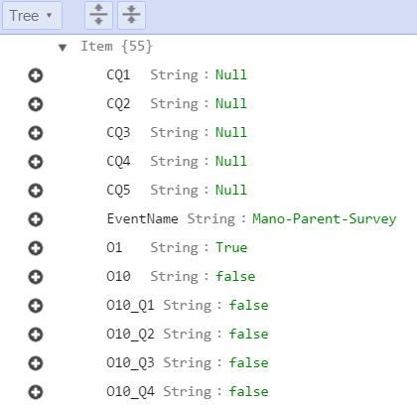

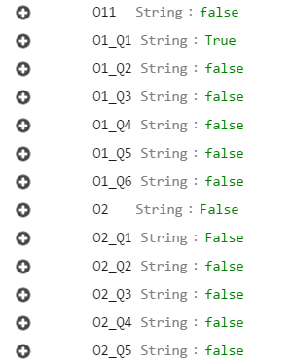

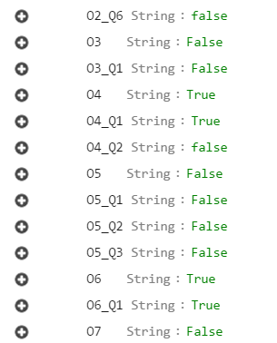

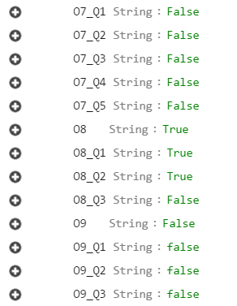

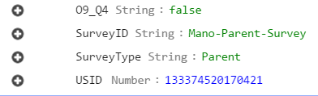

Data Table: Respondent

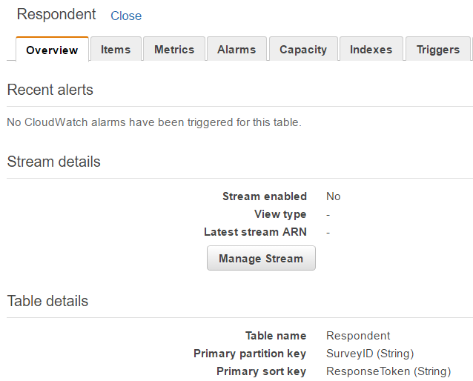

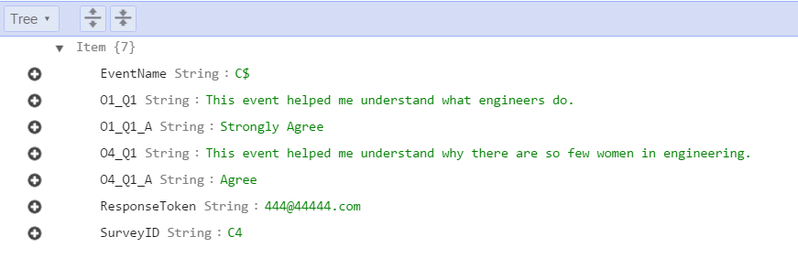

Data Table: ObjectivesDB

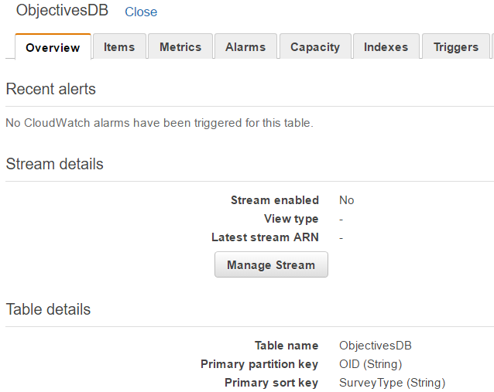

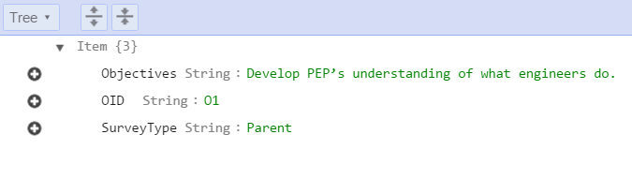

Data Table: QuestionsDB

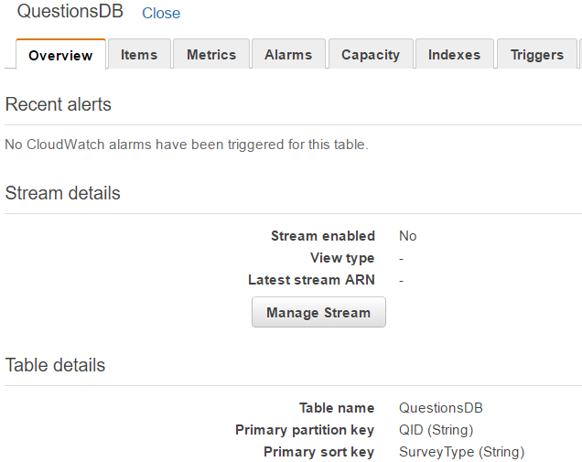

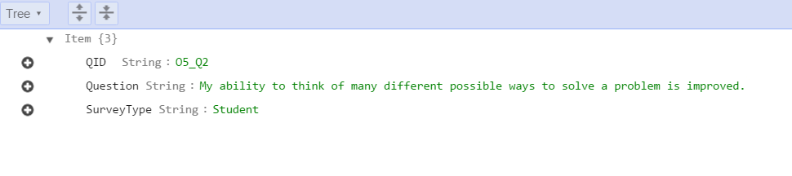

Data Table: Roles

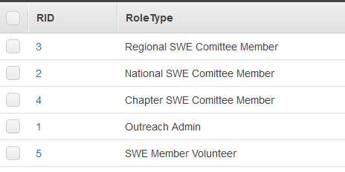

# Section 4: Architecture

Below is standard underlying Architecture of SWE OAWP. User management module from the following architecture is mostly covered. Basic skeleton of Feedback module is accomplished and Survey module is still in progress.

* 1. SWE OAWP: Society of Women Engineers Online Assessment Web Portal.
  2. User Management Module: Module developed to manage SWE member’s access to the portal.
     1. Role Manager: Module under 1.1 to manage roles of SWE Members.
     2. Login Module: Module under 1.1 to validate entry of user for secure access.
        1. Secure Login: Module under 1.1.2 to cross check entered password with encrypted password.

of user.

* + - 1. Privileged Access: Module under 1.1.2 to check for particular role
    1. Users Administration: Module to administer SWE Member users in repository.
       1. Indexer: Lists all the existing users.
       2. Add: Add user to repository.

and salt.

1.1.3.2.1 Password Encryption: Encrypt password using MD5

* + - 1. Edit: Edit any existing user.
      2. Delete: Delete any existing user.
  1. Feedback Analyzer: Module under 1.0 to manage feedback processing and exhibition.
     1. Feedback Retriever: Module to receive data from survey.
        1. Direct Feedback Module: Module which will enable SWE members to feed in survey.
        2. Online Feedback Module: Module which will receive data from electronic surveys taken by general public.

1.2.1.2.1 Resilience Module: Module which will handle network latencies, interrupts and exceptions.

* + 1. Feedback Processor: Module which will process the data gathered by retriever module.
       1. Chapter Level Report: Module which will generate Chapter Level Report data.

data.

* + - 1. State Level Report: Module which will generate State Level Report
      2. National Level Report: Module which will generate National Level Report data.
    1. Feedback Blaze: Module which will exhibit the data.
       1. Dashboard: Platform on which data will be shown in graphical form.
       2. Access Manager: Module which will control access to dashboard.
  1. Survey Engine: Module under 1.0 to manage surveys.
     1. Survey Generator: Module under 1.3 to generate surveys.
        1. Paper Survey: Module to generate softcopies of surveys e.g.

*.pdf,*.doc/x. – Future work.

* + - 1. Electronic Survey: Module to generate online surveys.

1.3.1.2.1 Deployment: Module under 1.3.1.2.1 to deploy online surveys to general public.

* + 1. Survey Saver: Module under 1.3 to save surveys.
    2. Reactivator and Eraser: Module to deactivate/reactivate and remove surveys.

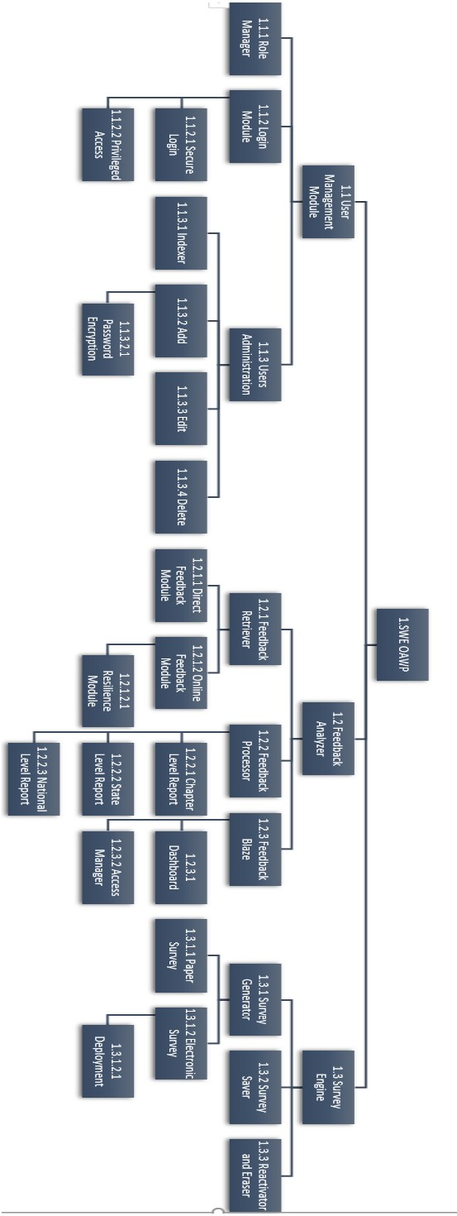

# Section 5: SWE OAWP at Runtime

1. Home.

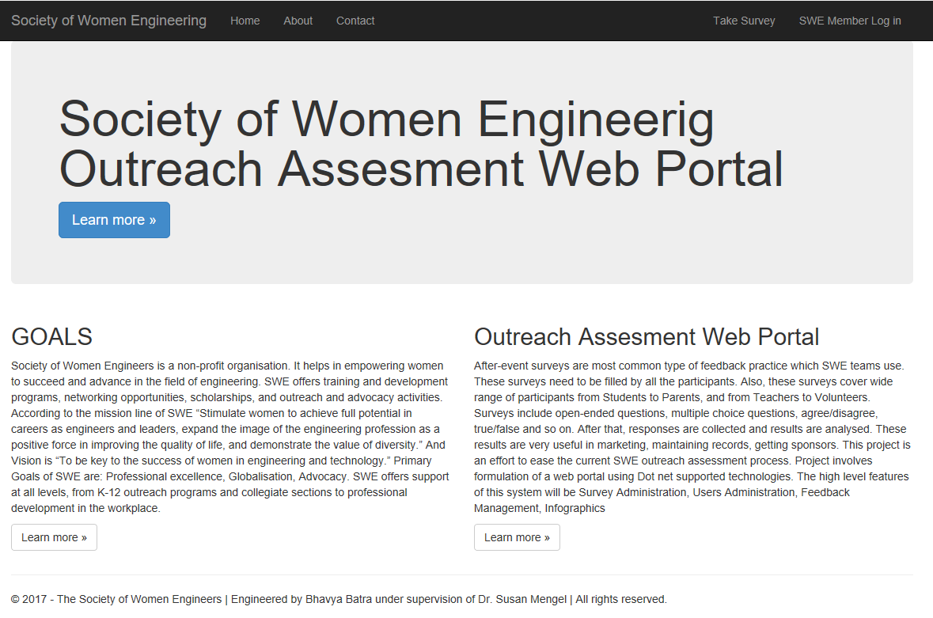

1. About

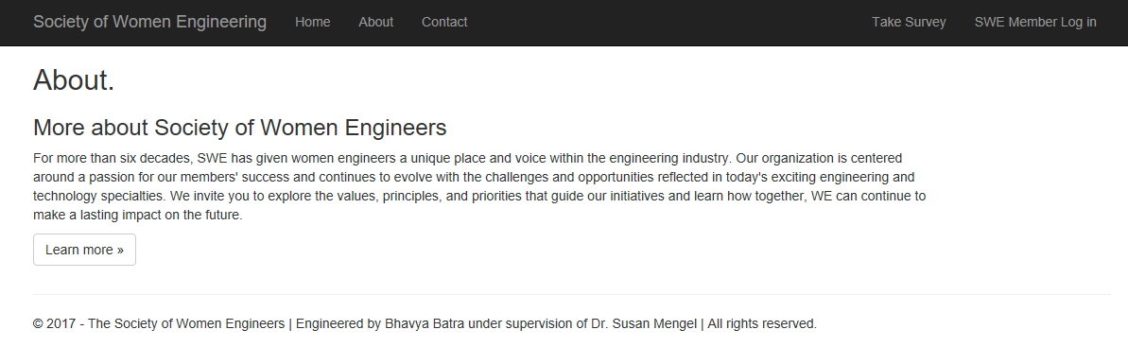

1. Contact

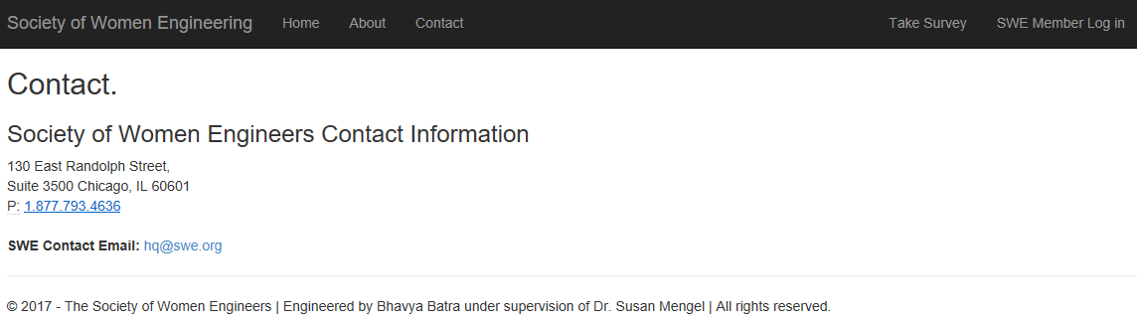

1. SWE Member Login
   * Login from Registered Email Address

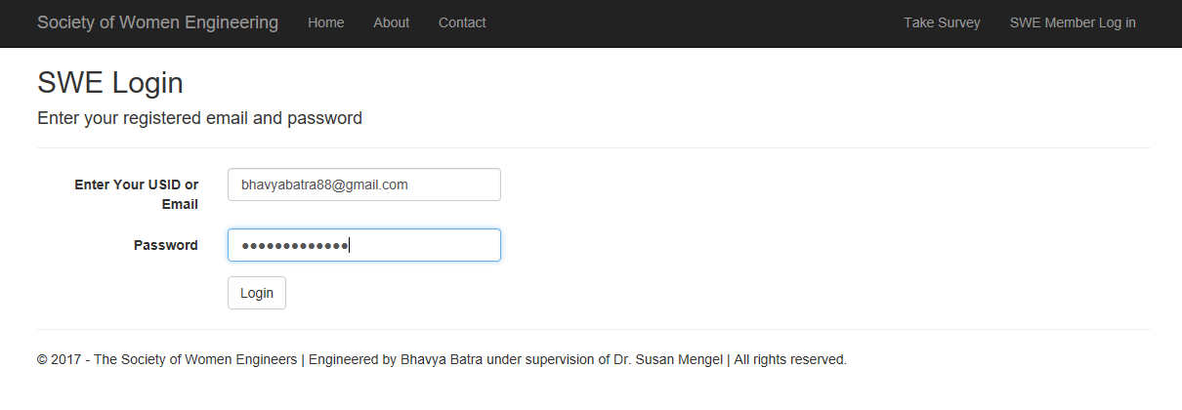

* + Login from User ID

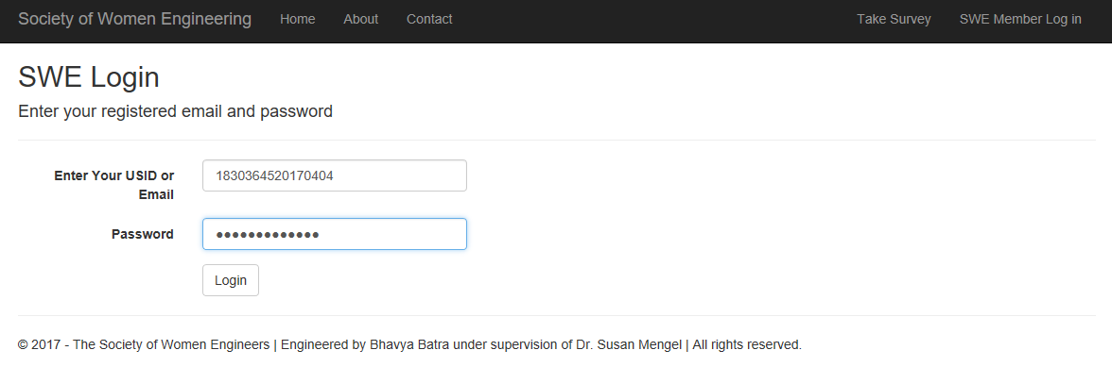

1. SWE Dashboard

SWE Outreach Administrator Dashboard

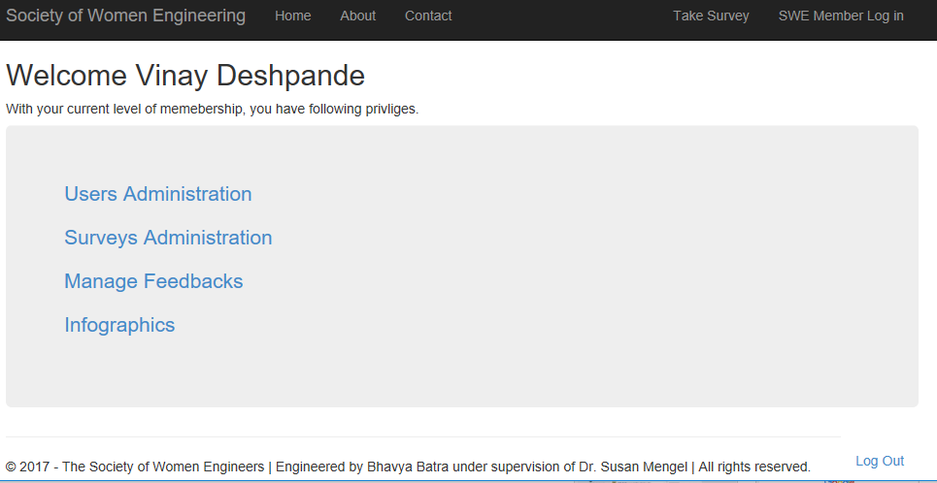

SWE National, Regional, Chapter Level Member Dashboard

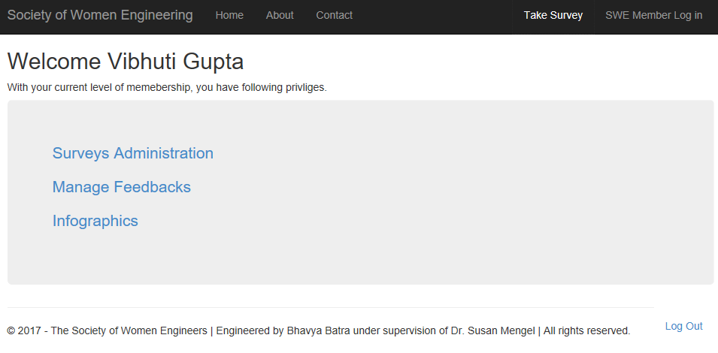

SWE Volunteer Dashboard

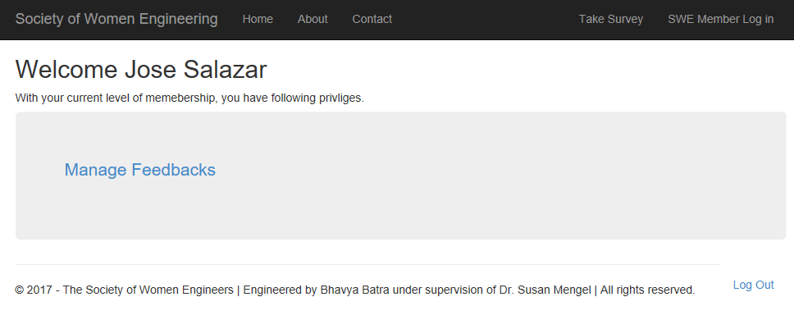

1. Users Administration

* + SWE Members Catalog

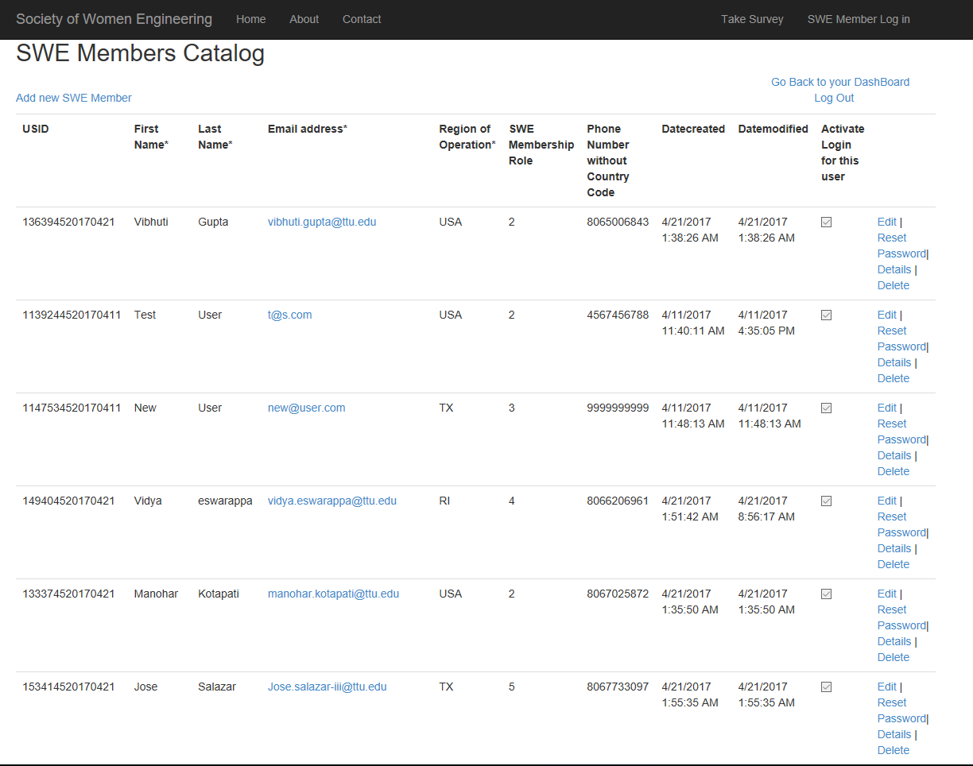

* + Add new SWE Member

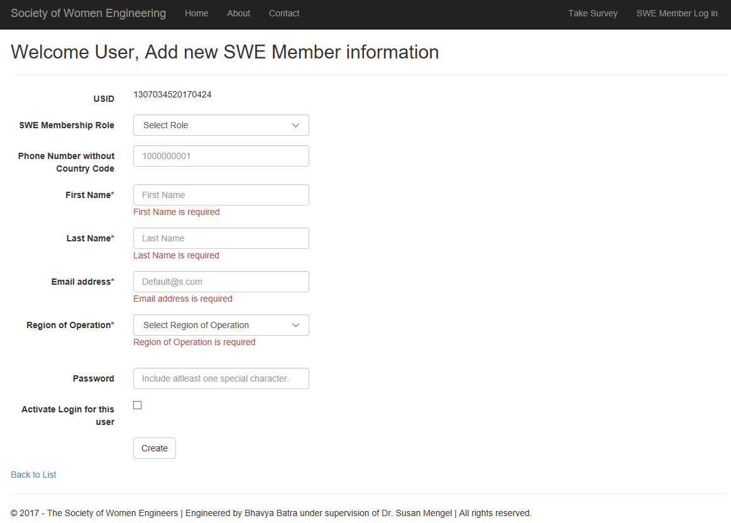

* + Edit Users

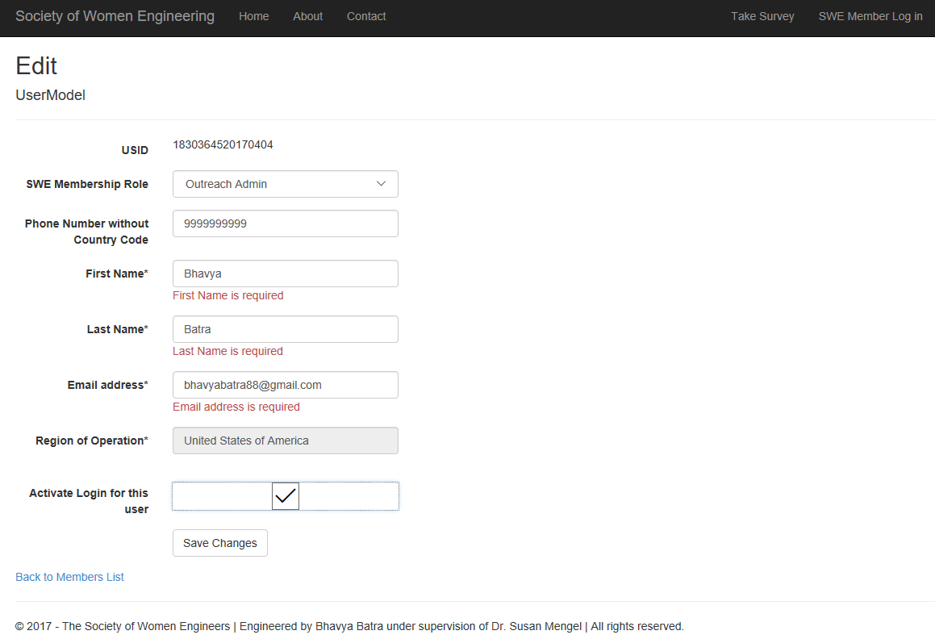

* + View Details of Users

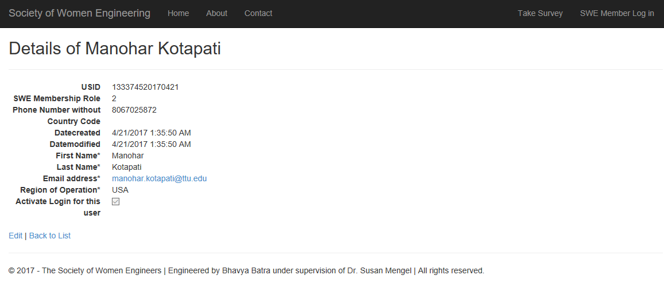

* + Delete User account

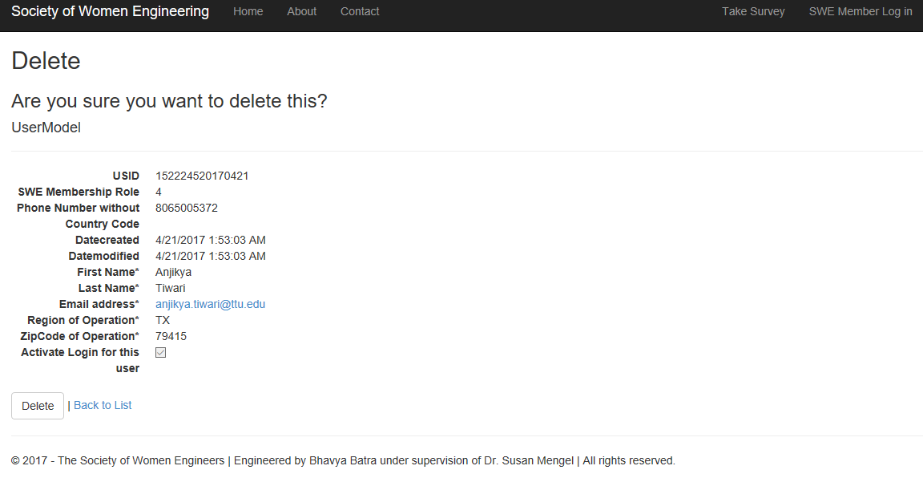

1. Surveys Administration
   * Survey List –

Admin View

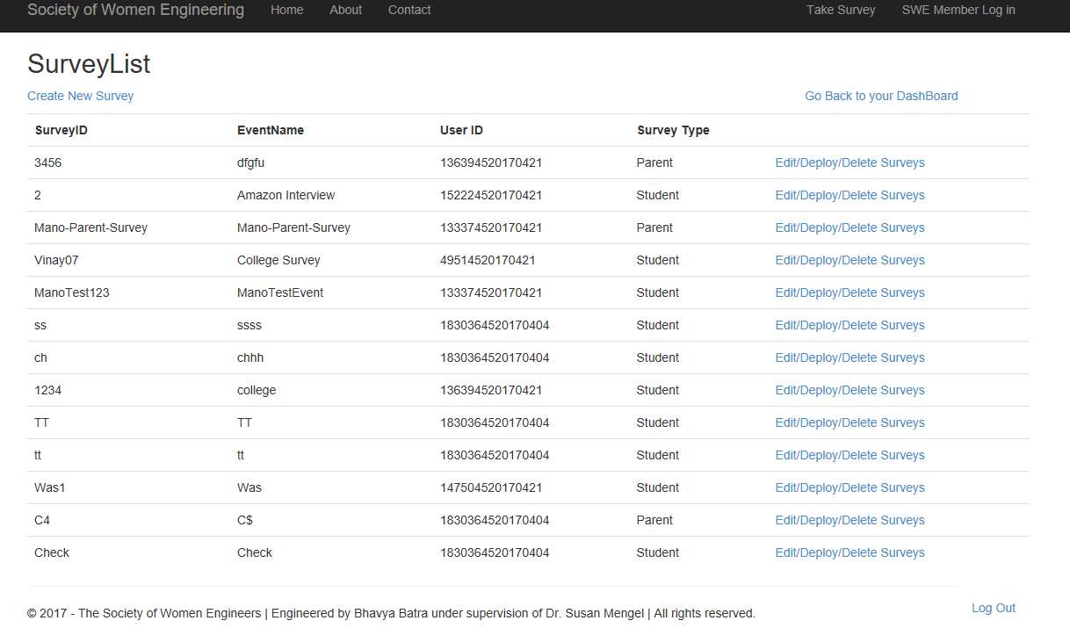

Member View

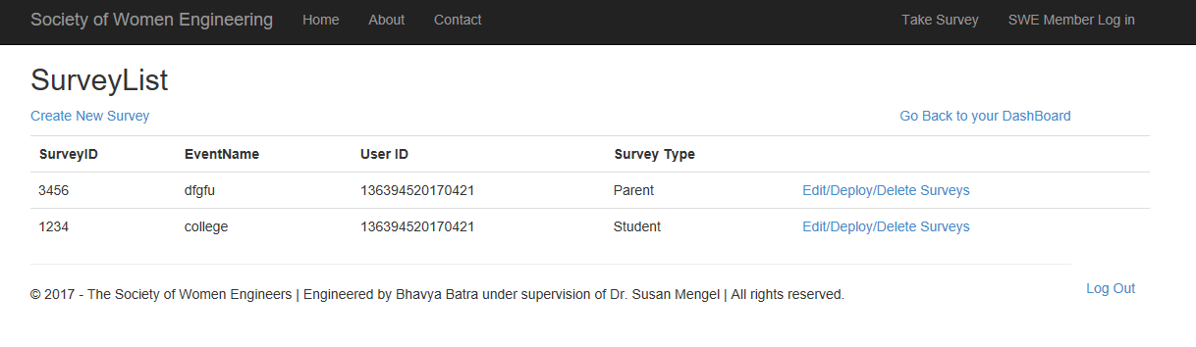

* + Create Survey

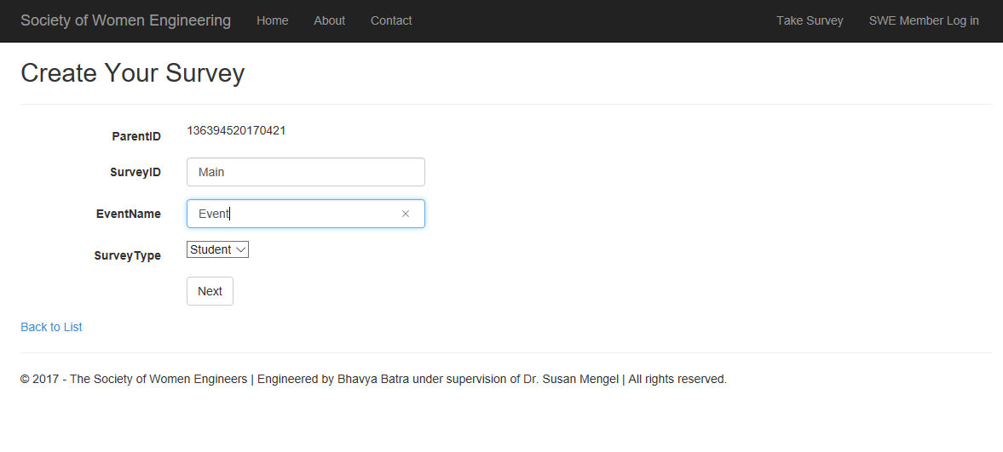

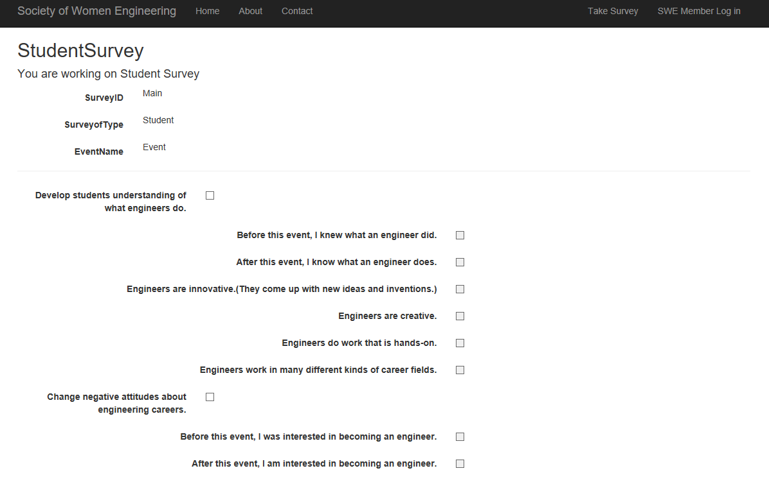

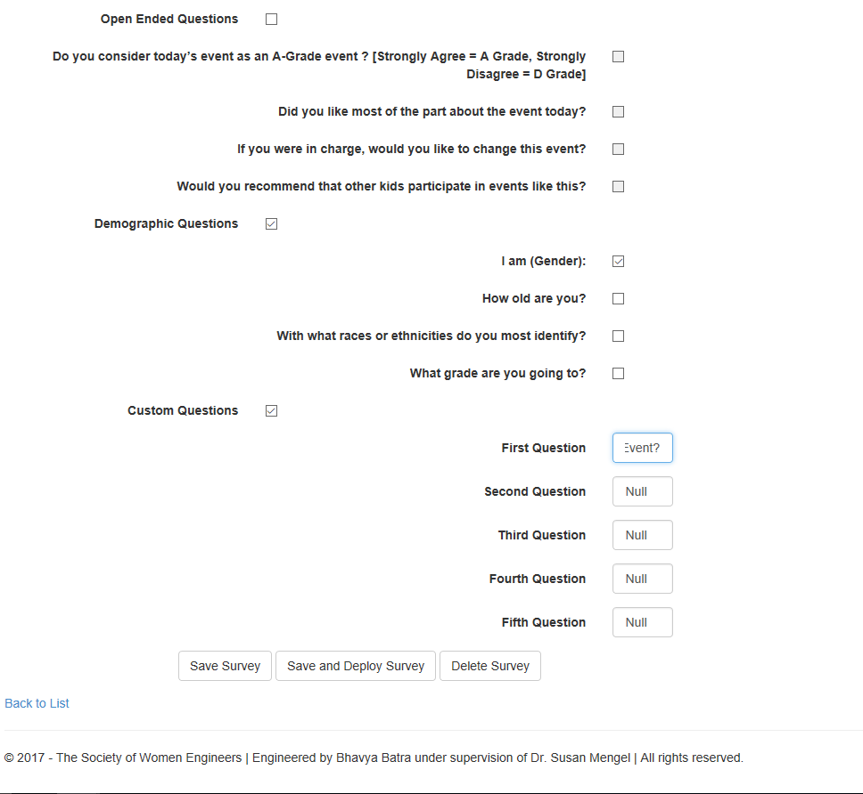

* + Deploy Survey

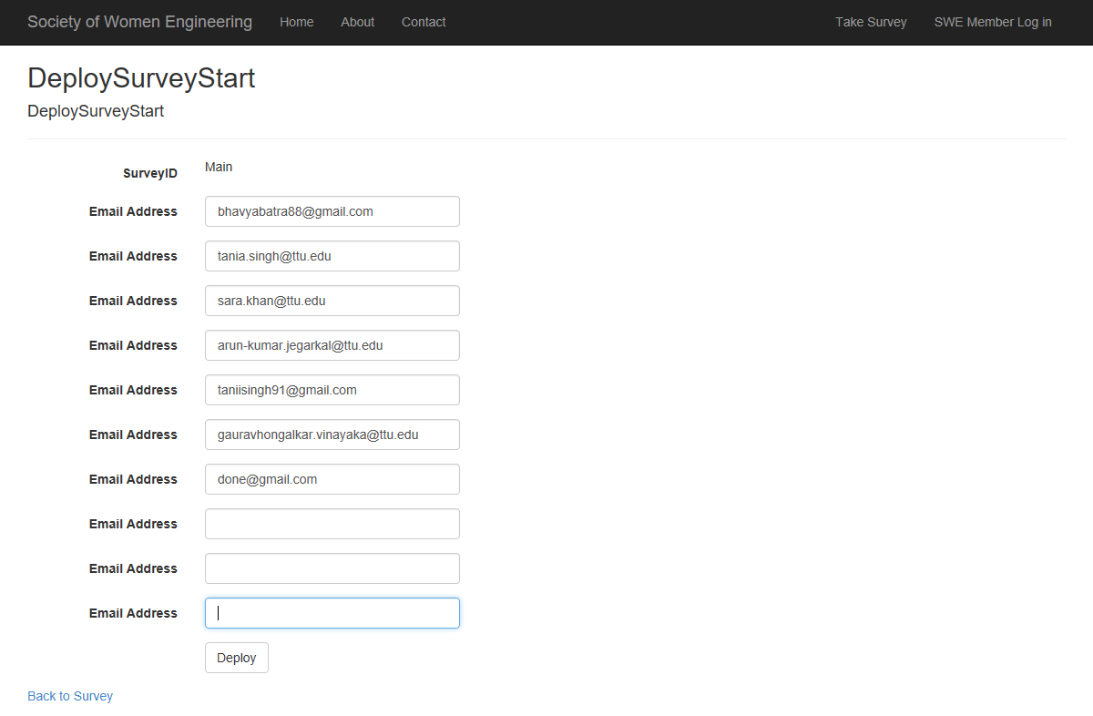

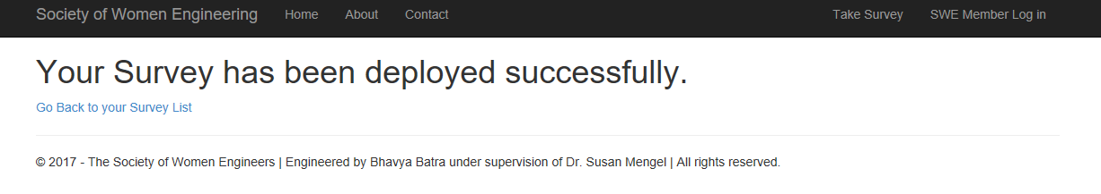

* + Edit /Delete Survey

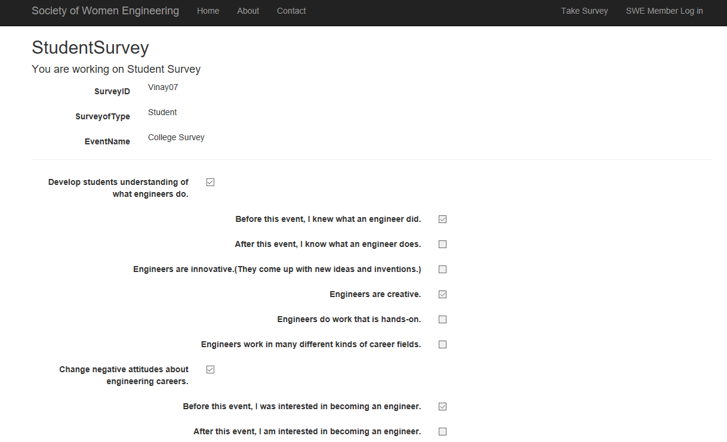

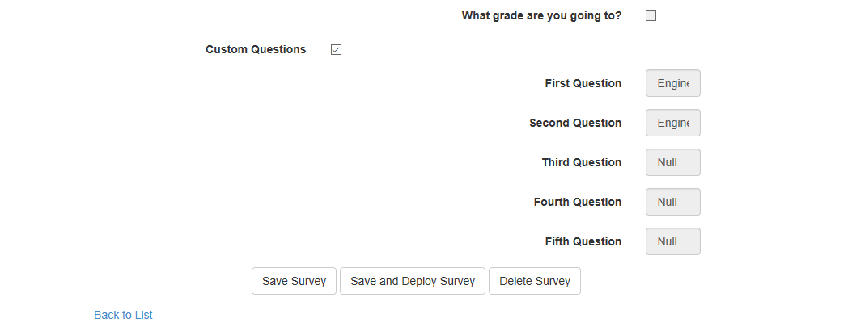

1. Manage Feedbacks
   * Admin\National Level Member View

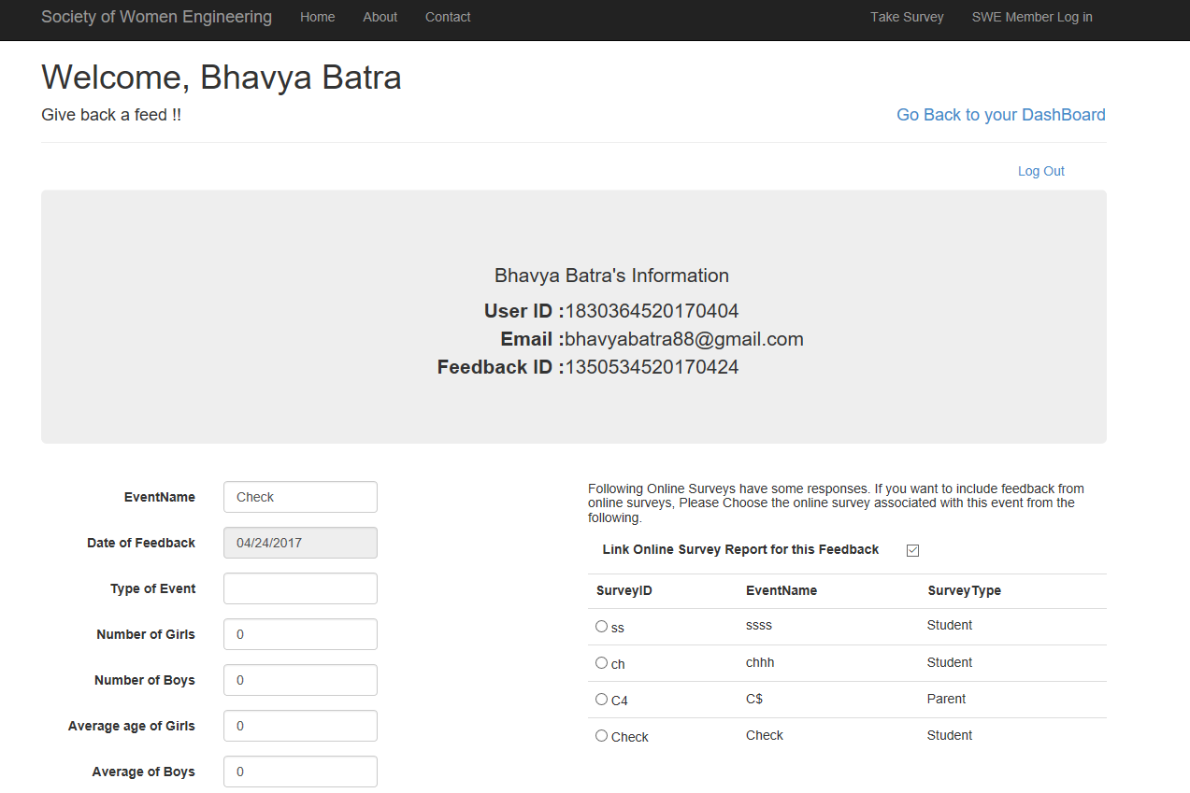

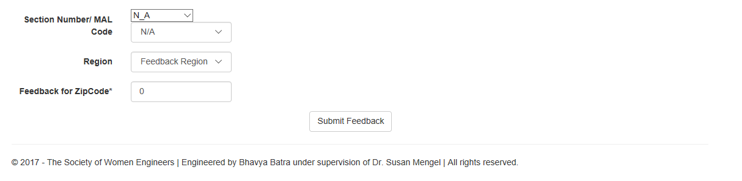

* + Regional Level Member View

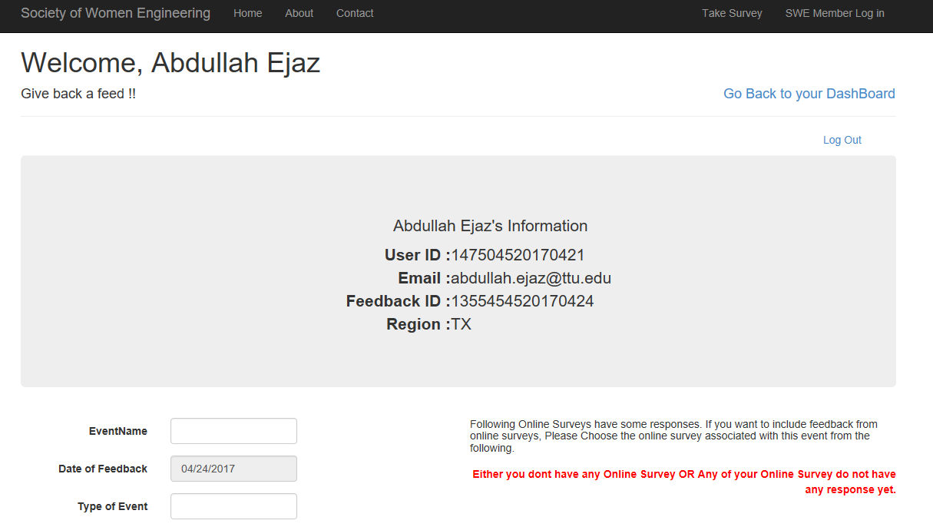

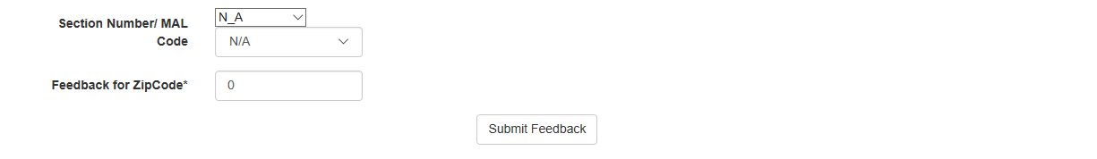

* + Chapter Level\ SWE Volunteer View

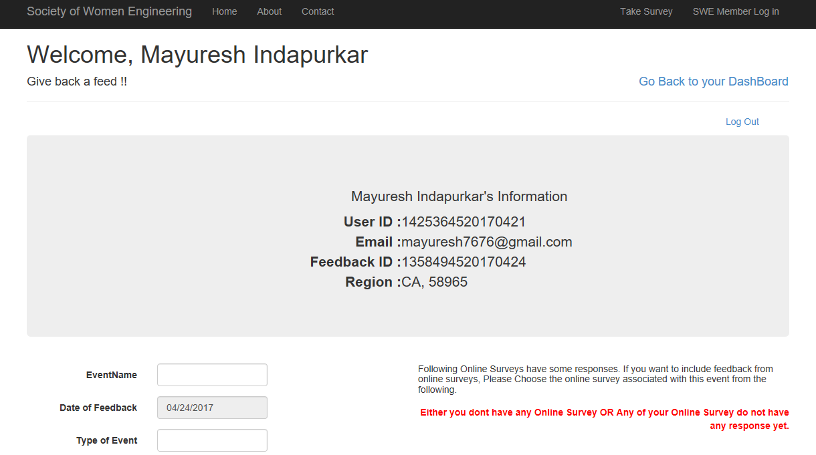

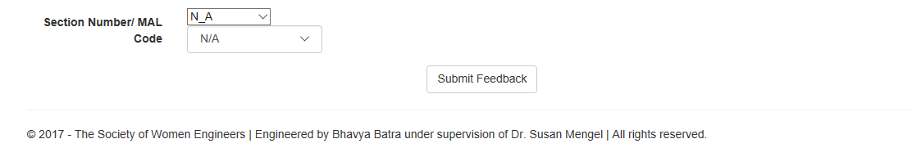

1. Infographics
   * Outreach Admin/ National Level View

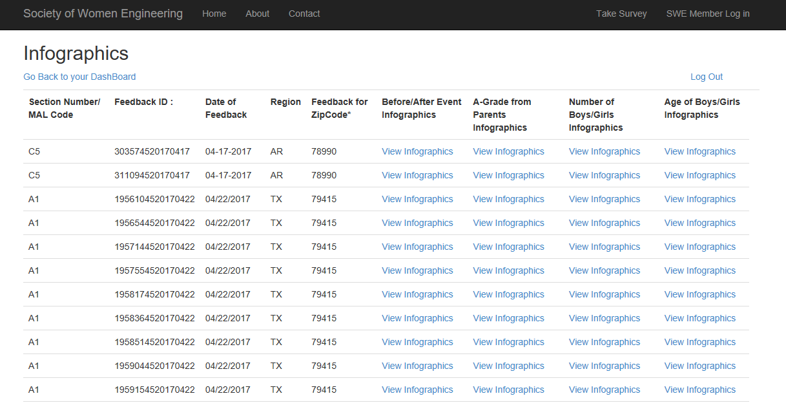

* + Regional Level View

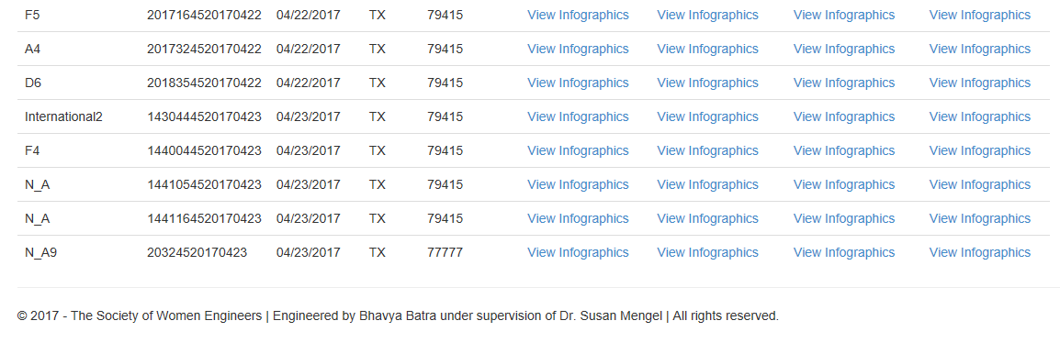

* + Chapter Level View

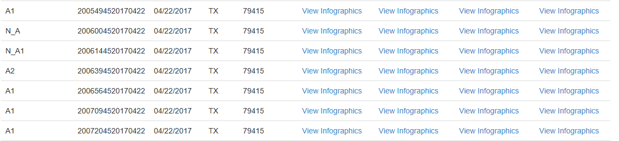

* + Before/After Event Infographics

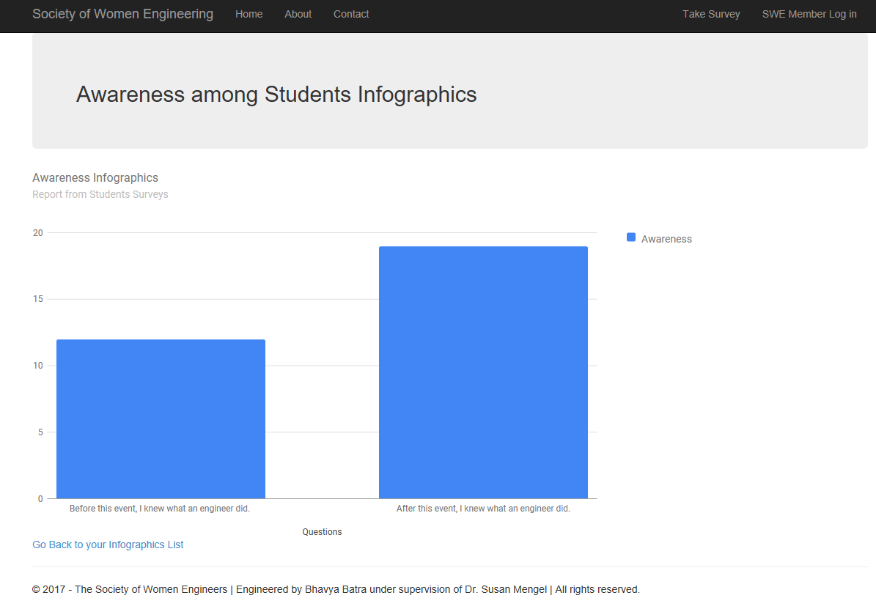

* + A-Grade from Parents Infographics

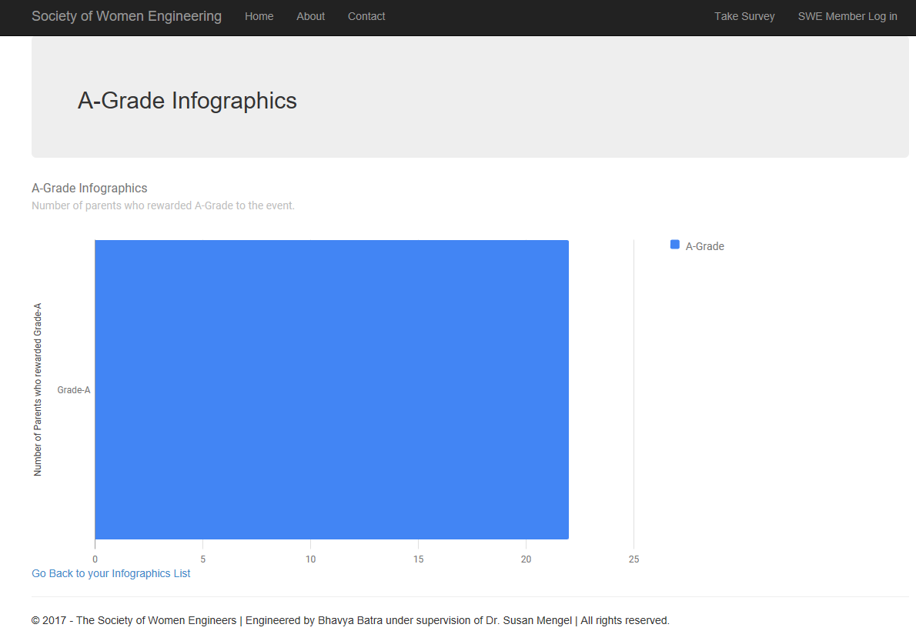

* + Number of Boys/Girls Infographics

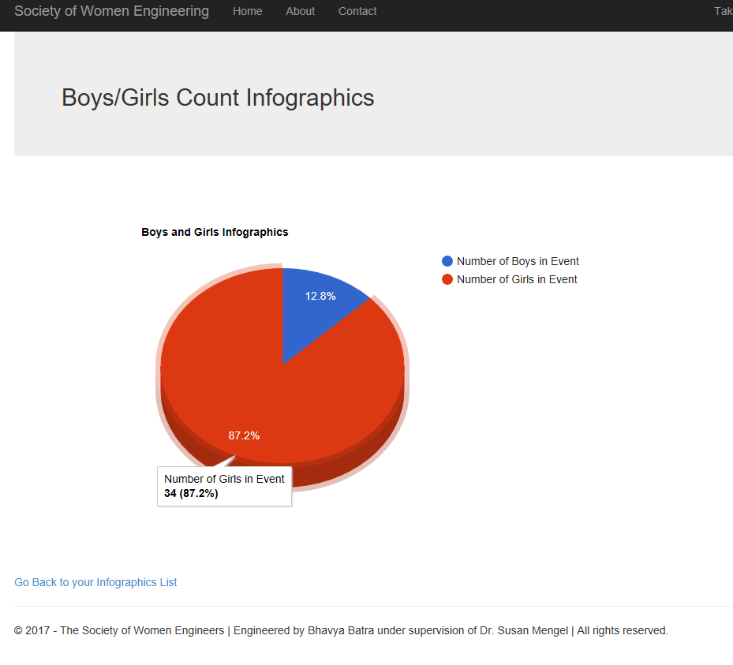

* + Age of Boys/Girls Infographics

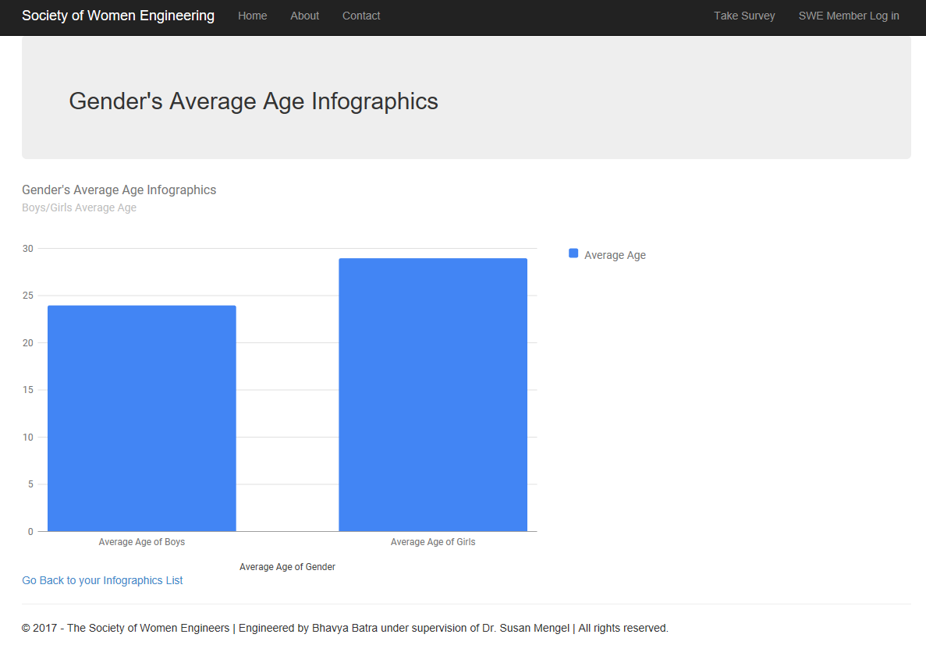

1. Take Survey

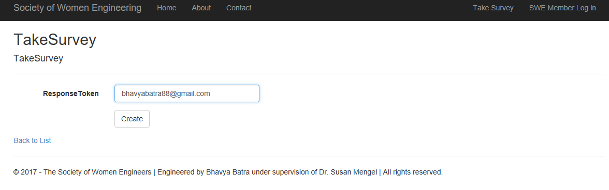

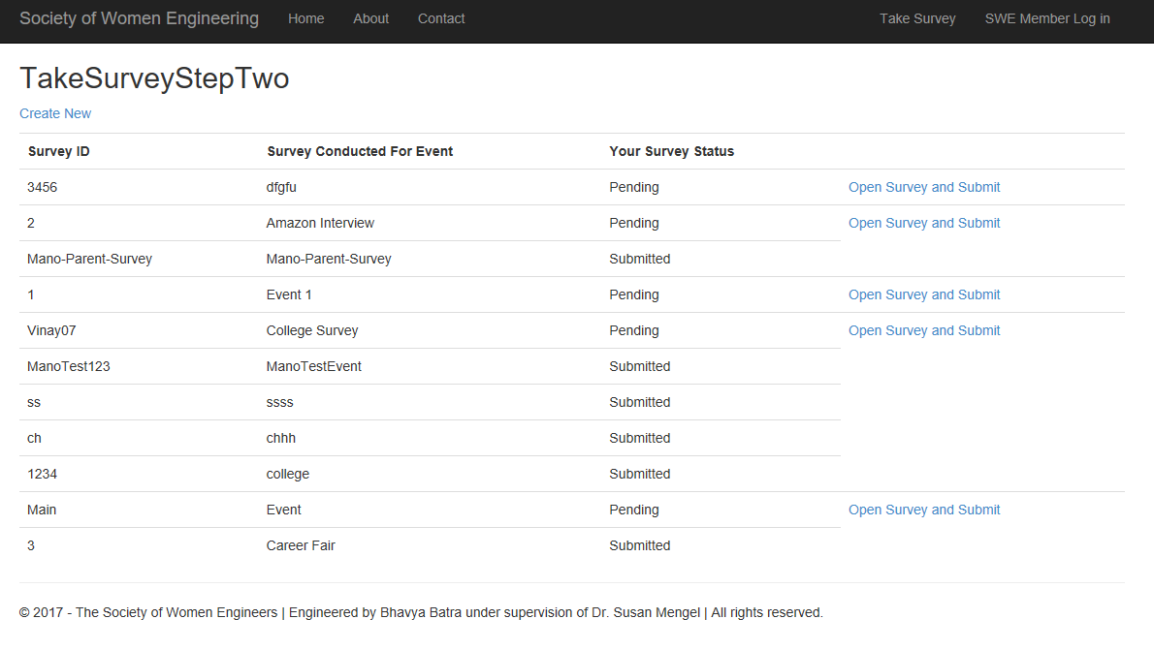

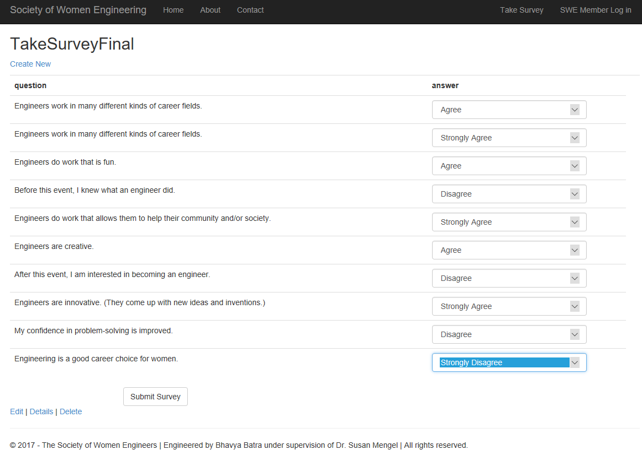

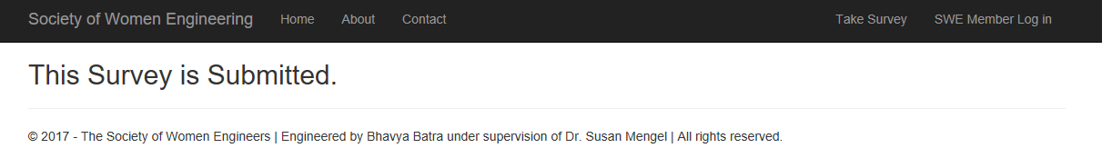

# Section 6: Activity Diagrams

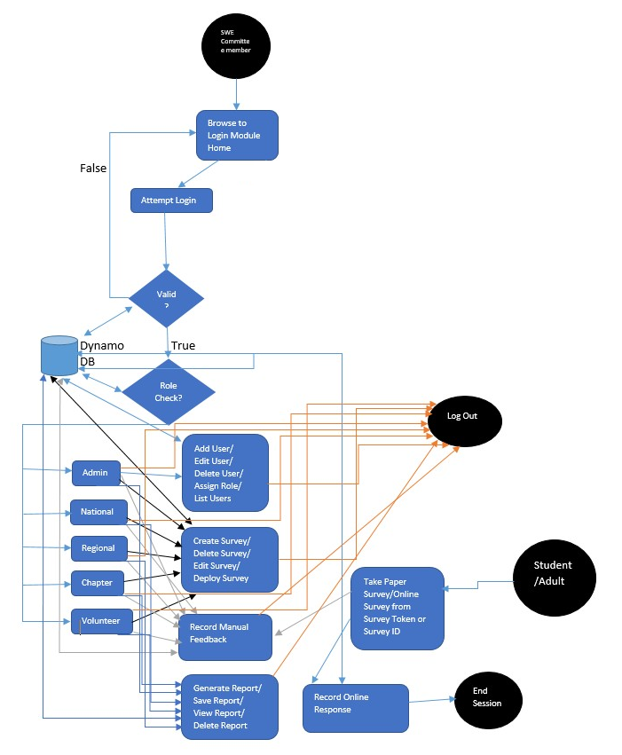

* 1. LOGIN

Login activity flow diagram describes login activity of members. And how they will land on different home pages once login credentials and role membership is validated.

* 1. Role Manager

This is flow of control up till the platform where user with the admin role could manage the roles of SWE Members. It is responsible for user’s landing on correct role page if user login is active.

* 1. Users Administration

This is continuation of Administrator activity from its Admin home page where s/he can add, omit and emit, list member users.

* 1. Surveys Administration

This section enables committee members to create, delete, update and deploy the surveys.

* 1. Feedback Management

This section enables members and participants to record feedback of generated surveys whether manually or online.

* 1. Infographics

In this section, user with appropriate privileges can view graphical reports on Gender Ration, A-Grade, Average Age and awareness increase.

# Section 7: Use Case Diagram

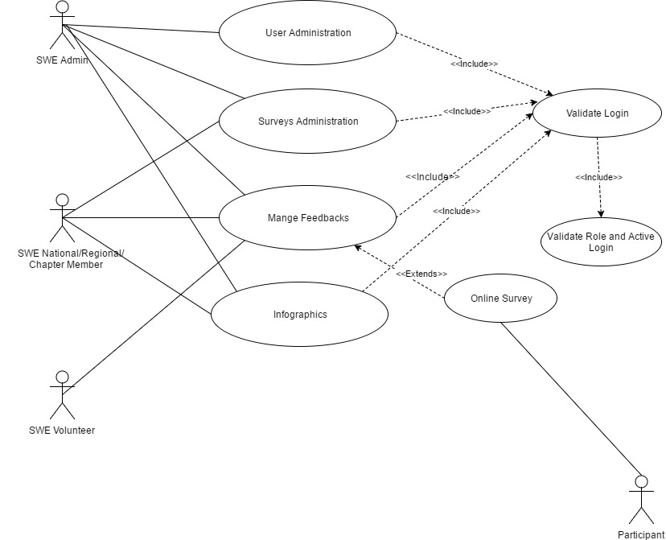

SWE OAWP broadly has four category of actors: -

* + 1. SWE Admin – Use cases for any SWE Admin Are User management, Survey Management, Feedback Management, Reporting Management.
    2. SWE Committee member – Use cases for any SWE Committee member are Survey Management, Feedback Management and Infographics.
    3. SWE Volunteer – The candidates doing volunteer work for SWE will have access to provide feedback after session.
    4. Survey Participants – Survey Participants can take online Student/Adult

survey depending upon age.

# Section 8: Sequence Diagrams

SWE OAWP broadly has four category of actors: -

# Section 9: Testing

We have performed thorough unit testing and role based usability testing. Candidates were selected from varied domains and assigned with different roles: -

|  |  |  |  |
| --- | --- | --- | --- |
| #Number | Tester Name | Assigned Role | Department |
| 1 | Vinay Deshpande | Outreach Admin | CS |
| 2 | Manohar Kotapati | National Level Admin | CS |
| 3 | Vibhuti Gupta | National Level Admin | CS |
| 4 | Abdullah Ejaz | Regional Level Admin | CS |
| 5 | Phani Cherukuri | Regional Level Admin | CS |
| 6 | Vidya Eswarappa | Chapter Level Admin | CS |
| 7 | Anjikya Tiwari | Chapter Level Admin | CS |
| 8 | Jose Salazar | SWE Volunteer | Law |
| 9 | Gaurav Vinayaka | SWE Volunteer | CS |
| 10 | Mayuresh Indapurkar | SWE Volunteer | Data Science |
| 11 | Tania Singh | Participant | Law |
| 12 | Sara Khan | Participant | Law |
| 13 | Arun Jegarkal | Participant | CS |
| 14 | Vinay Deshpande | Participant | CS |
| 15 | Bhavya Batra | Participant | CSSE |

These candidates then ran set of test cases and recorded their results, following are the attached results.

**Results of Testing by Manohar Kotapati**

|  |  |  |  |  |  |
| --- | --- | --- | --- | --- | --- |
| Test Case No. | | Test cases for National Level Administrators (Please Execute following test cases for 5-10 times) | Expected Results | Actual Results | Status |
| 1 | Login with your User ID Provided . | Successful login | Login successful | Pass |
| 2 | Login with your Email Provided. | Successful login | Login successful | Pass |
| 3 | Put incorrect password for your login | Unsuccessful login | Unsuccessful login - Login Failed Message | Pass |
| 4 | You should see Survey administration, Manage Feedback and Infographics links. |  | Able to see Survey administration, Manage Feedback and Infographics links. | Pass |
| 5 | Click on Survey Admin and create a "Student" survey. Select minimum 3 and maximum 5 head topics and then any number of questions in those topics. | Survey Should be created deployed successfully. It may take some time. | Survey Created | Pass |
| 6 | Deploy Survey to following users :- sara.khan@ttu.edu tania.singh@ttu.edu arun-kumar.jegarkal@ttu.edu bhavyabatra88@gmail.com vinay.deshpande18@gmail.com | Survey Should be created deployed successfully. It may take some time. | Deployed to 5 users. But took more time. | Pass |
| 7 | Click on Survey Admin and create a "Parent" survey. Select minimum 3 and maximum 5 head topics and then any number of questions in those topics. | Survey Should be created deployed successfully. It may take some time. | Parent Survey Created | Pass |
| 8 | Deploy Survey to following users :- sara.khan@ttu.edu tania.singh@ttu.edu arun-kumar.jegarkal@ttu.edu bhavyabatra88@gmail.com vinay.deshpande18@gmail.com | Survey Should be created deployed successfully. It may take some time. | Deployed to 5 users. But took more time and Outlook new mail pop-up getting arrived with email id 444@44444.com | Pass |
| 9 | Go back to survey List. | You should be able to see your surveys. | Feedback Submitted+A1:F9+D10:D11 | Pass |
| 10 | Go to Manage Feedback and put random values for data. Select any survey with answers if available and submit feedback. | Feedback should be submitted successfully. | Able to see Survey List | Pass |
| 11 | Go Infographics Section. You should be able see all the graphs for all states (if data available for other states.) | All graphs should be visible. | Couple of time Got Login failed error even the user is logged in | Pass |
|  | Random Tests. |  |  |  |
| 12 | Create random surveys |  |  |  |
| 13 | add and delete other surveys which are not deployed |  | able to delete, add surveys |  |
| 14 | don’t include online surveys even if exist. |  |  |  |

**Results of Testing by Vibhuti Gupta**

|  |  |  |  |  |
| --- | --- | --- | --- | --- |
| Test Case No. | Test cases for National Level Administrators (Please Execute following test cases for 5-10 times) | Expected Results | Actual Results | Status |
| 1 | Login with your UserID Provided . | Successful login | Successful login | Pass |
| 2 | Login with your Email Provided. | Successful login | Successful login | Pass |
| 3 | Put incorrect password for your login | Unsuccessful login | Unsuccessful login | Pass |
| 4 | You should see Survey administration, Manage Feedback and Infographics links. |  | Yes | Pass |
| 5 | Click on Survey Admin and create a "Student" survey. Select minimum 3 and maximum 5 head topics and then any number of questions in those topics. | Survey Should be created deployed successfully. It may take some time. | Yes | Pass |
| 6 | Deploy Survey to following users :- sara.khan@ttu.edu tania.singh@ttu.edu arun-kumar.jegarkal@ttu.edu bhavyabatra88@gmail.com vinay.deshpande18@gmail.com | Survey Should be created deployed successfully. It may take some time. | Yes | Pass |
| 7 | Click on Survey Admin and create a "Parent" survey. Select minimum 3 and maximum 5 head topics and then any number of questions in those topics. | Survey Should be created deployed successfully. It may take some time. | Yes | Pass |
| 8 | Deploy Survey to following users :- sara.khan@ttu.edu tania.singh@ttu.edu arun-kumar.jegarkal@ttu.edu bhavyabatra88@gmail.com vinay.deshpande18@gmail.com | Survey Should be created deployed successfully. It may take some time. | Yes | Pass |
| 9 | Go back to survey List. | You should be able to see your surveys. | Yes | Pass |
| 10 | Go to Manage Feedback and put random values for data. Select any survey with answers if available and submit feedback. | Feedback should be submitted successfully. | Yes | Pass |
| 11 | Go Infographics Section. You should be able see all the graphs for all states (if data available for other states.) | All graphs should be visible. | Yes-Fail a couple of times, but then succeeded. | Pass |
|  | Random Tests. |  |  |  |
| 12 | Create random surveys |  |  |  |
| 13 | add and delete other surveys which are not deployed |  | Yes | Pass |
| 14 | don’t include online surveys even if exist. |  |  |  |

**Results of Testing by Joe Salazar**

|  |  |  |  |  |
| --- | --- | --- | --- | --- |
| Test Case No. | Test cases for SWE Volunteers (Please Execute following test cases for 5-10 times) | Expected Results | Actual Results | Status |
| 1 | Login with your User ID Provided . | Successful login | Successful Login | Pass |
| 2 | Login with your Email Provided. | Successful login | Successful Login | Pass |
| 3 | Put incorrect password for your login | Unsuccessful login | Unsuccessful Login | Pass |
| 5 | When you login, you land on your dashboard. | You should see Feedback Management and your name on the top. | Exactly as expected | Pass |
| 6 | Click on Feedback Link and submit feedback with random numbers. You can select any values, enter any values. Select any section codes. Select any section numbers. And submit feedback. (Please submit random 50 feedbacks.) | Your feedback should be submitted successfully every time. | 50+ Successful Submissions | Pass |
| 7 | Logout | Logout should be successful | Successful log out | Pass |

**Results of Testing by Vidya Eswarappa**

|  |  |  |  |  |
| --- | --- | --- | --- | --- |
| Test Case No. | Test cases for National Level Administrators (Please Execute following test cases for 5-10 times) | Expected Results | Actual Results | Status |
| 1 | Login with your UserID Provided . | Successful login | login successful | PASS |
| 2 | Login with your Email Provided. | Successful login | login successful(welcome page) | PASS |
| 3 | Put incorrect password for your login | Unsuccessful login | unsuccessful login with error message | PASS |
| 4 | You should see Survey administration, Manage Feedback and Infographics links. | Menu List | Menu List as Expected | PASS |
| 5 | Click on Survey Admin and create a "Student" survey. Select minimum 3 and maximum 5 head topics and then any number of questions in those topics. | Survey Should be created deployed successfully. It may take some time. | survey is created | PASS |
| 6 | Deploy Survey to following users :- sara.khan@ttu.edu tania.singh@ttu.edu arun-kumar.jegarkal@ttu.edu bhavyabatra88@gmail.com vinay.deshpande18@gmail.com | Survey Should be created deployed successfully. It may take some time. | survey deployed successfully for the provided email id. | PASS |
|  |  |  |  |  |
|  |  |  |  |  |
| 9 | Go back to survey List. | You should be able to see your surveys. | Surveys created are present in survey list. | PASS |
| 10 | Go to Manage Feedback and put random values for data. Select any survey with answers if available and submit feedback. | Feedback should be submitted successfully. | Feedback submitted successfully | PASS |
| 11 | Go Infographics Section. You should be able see all the graphs for all states (if data available for other states.) | All graphs should be visible. | Graphs are visible as expected. | PASS |
|  | Random Tests. |  |  |  |
| 12 | Create random surveys |  |  |  |
| 13 | add and delete other surveys which are not deployed |  | able to add and delete surveys before deployment | PASS |
| 14 | don’t include online surveys even if exist. |  |  |  |

**Results of Testing by Vinay Deshpande**

|  |  |  |  |
| --- | --- | --- | --- |
| Test Case | Expected Result | Actual Result | Status |
| Login. - Positive Credentials | Successful Login with User Administration, Survey Administration, Manage Feedback and Infographics. | Logged in Successfully with User administration, Survey Administration, Manage Feedback and Infographics. | Pass |
| Login. - Negative Credentials | Error Screen. | Login in Failed, Please try to Log in Again | Pass |
| Test all the links and navigation to SWE.org. | No links should be broken. | All the Links navigate to SWE.org | Pass |
| After Login, go to User Administration and create national level users, regional level users, chapter level user and swe volunteer accounts. Add random information. Manohar Kotapati - National Level Volunteer Vibhuti Gupta - National Level Member Phani Chekuri - Regional Level Member Abdulha - Regional Level Member vidya - Chapter Level Member Anjikya - Chapter Level Member Joe Salazar - SWE Volunteer gaurav-Swe volunteer | Every user should get created successfully. | All The users created Successfully | Pass |
| Go to Survey Administration -> Create a Student Sruvey -> Select min 3 max 5 random objectives and then select any number of questions in those objectives. (including custom questions) and then deploy. Survey to :- sara.khan@ttu.edu tania.singh@ttu.edu arun-kumar.jegarkal@ttu.edu bhavyabatra88@gmail.com | Deployment should Succeed. | The Surveys are deployed successfully. | Pass |
| After getting few responses go to feed back section and enter random values. | Include online feedback of reported data | The Feedbacks have been recorded successfully | Pass |
| Go to infographics section and check all graphs are showing | all graphs should be displayed successfully. | Graphs renders accurate results | Pass |
| Random Tests. | Test Navigation, button . | All the buttons, links and indentation of data is perfectly in working condition | Pass |
| add other more users apart from above. | Add users | users Added Successfully | Pass |
| delete users | The user should be deleted from the database | The user is deleted from the database also deleted user is not a part of the member list | Pass |
| add and delete surveys | The survey should be added and deleted from the survey list | The survey added and deleted from the survey list | Pass |
| try reseting a password for and user apart from list. | The password should be reset | The Password has been reset successfully | Pass |
|  |  |  | Pass |
|  |  |  |  |
|  |  |  |  |
| Number of Test Cases | **Number of Test Cases Passed** | **Number of Test Cases Failed** |  |
| 14 | **14** | **0** |  |
|  |

**Results of Testing by Tania Singh**

|  |  |
| --- | --- |
| Test | Status |
| Login to participant panel. | Success |
| Visible List of Submitted and pending Surveys. | Success |
| No link to open Submitted Surveys. | Success |
| Opened pending surveys successfully. | Success |
| Answered Dropdown and Custom Questions successfully. | Success |
| Survey Submitted Successfully. | Success |
| Survey Status changed from pending to submitted. | Success |

**Results of Testing by Arun Jegarkal**

|  |  |
| --- | --- |
| Test | Status |
| Login to participant panel. | Pass |
| Visible List of Submitted and pending Surveys. | Pass |
| No link to open Submitted Surveys. | Pass |
| Opened pending surveys successfully. | Pass |
| Answered Dropdown and Custom Questions successfully. | Pass |
| Survey Submitted Successfully. | Pass |
| Survey Status changed from pending to submitted. | Pass |